OBJECT ORIENTED PROGRAMMING- I

1. Write a Program that displays Welcome to Java, Learning Java Now and Programming is fun.

public class Welcome

{

public static void main(String arg[])

{

System.out.println("Welcome to java");

System.out.println("Learning java now");

System.out.println("Programming is fun!!");

}

}

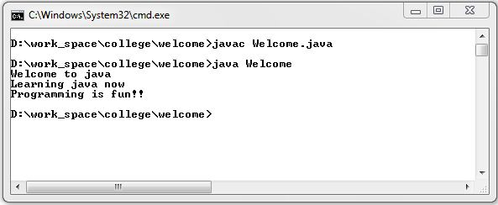

1. Write a program that solves the following equation and displays the value x and y:

1) 3.4x+50.2y=44.5 2) 2.1x+.55y=5.9 (Assume Cramer’s rule to solve equationax+by=e x=ed-bf/ad-bccx+dy=f y=af-ec/ad-bc )

import java.util.Scanner;

class Eq

{

public static void main(String arg[])

{

Scanner ob = new Scanner(System.in);

System.out.print("Give the values of a,b,c,d,e,f: \n");

Float a = ob.nextFloat();

Float b = ob.nextFloat();

Float c = ob.nextFloat();

Float d = ob.nextFloat();

Float e = ob.nextFloat();

Float f = ob.nextFloat();

Float count = a*d-b*c;

if(count==0)

{

System.out.println("The equation has no solution found");

}

else

{

Float x = (e*d-b*f)/count;

Float y = (a*f-e*c)/count;

System.out.println("The value of X ="+x);

System.out.println("The value of Y ="+y);

}

}

}

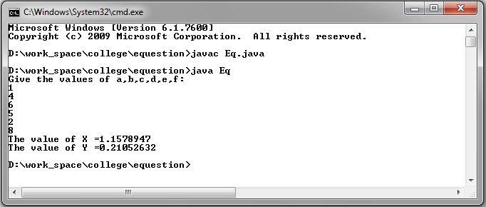

1. Write a program that reads a number in meters, converts it to feet, and displays the result.

import java.util.Scanner;

class Conversion

{

public static void main(String arg[])

{

Scanner sc = new Scanner(System.in);

System.out.println("Enter the value in meter \n");

Double meters = sc.nextDouble();

Double feet=3.28*meters;

System.out.println("The value in feet: "+feet);

}

}

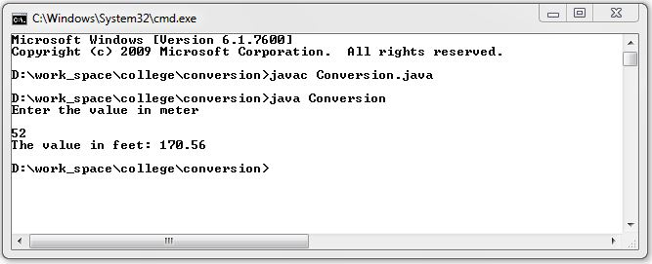

1. Body Mass Index (BMI) is a measure of health on weight. It can be calculated by taking your weight in kilograms and dividing by the square of your height in meters. Write a program that prompts the user to enter a weight in pounds and height in inches and displays the BMI. Note:- 1 pound=.45359237 Kg and 1 inch=.0254 meters.

import java.util.Scanner;

class Bmi

{

public static void main(String arg[])

{

Scanner ob = new Scanner(System.in);

System.out.println("Enter the weight in pounds:");

Double weight=ob.nextDouble();

System.out.println("Enter the height in inches");

Double height=ob.nextDouble();

Double wik=weight*0.45359237;

Double him=height*0.254;

Double BMI=wik/(him*him);

System.out.println("BMI is:"+BMI);

}

}

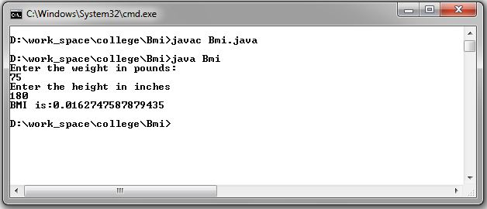

1. Write a program that prompts the user to enter three integers and display the integers in decreasing order.

import java.util.Scanner;

class Dec

{

public static void main(String arg[])

{

Scanner ob = new Scanner(System.in);

System.out.println("Enter three number ");

int num1=ob.nextInt();

int num2=ob.nextInt();

int num3=ob.nextInt();

int temp;

if(num2>num1||num3>num1)

{

if(num2>num1)

{

temp=num1;

num1=num2;

num2=temp;

}

if(num3>num1)

{

temp=num1;

num1=num3;

num3=temp;

}

if(num3>num2)

{

temp=num2;

num2=num3;

num3=temp;

}

}

System.out.println("Numbers in Decending order are:- ");

System.out.println(num1+" "+num2+" "+num3);

}

}

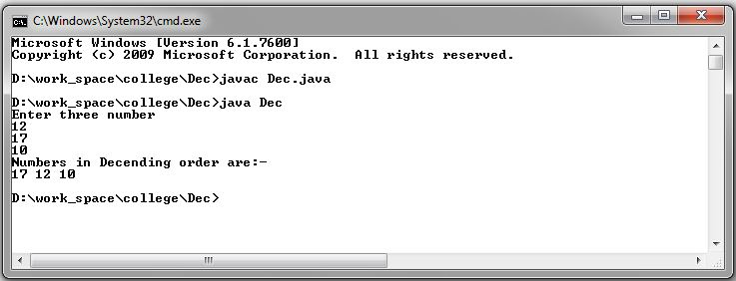

1. Write a program that prompts the user to enter a letter and check whether a letter is a vowel or constant.

import java.util.Scanner;

class VorC

{

public static void main(String arg[])

{

Scanner ob = new Scanner(System.in);

System.out.println("Enter a character");

char ch=ob.next().charAt(0);

if(ch=='a'||ch=='e'||ch=='i'||ch=='o'||ch=='u'||ch=='A'||ch=='E'||ch=='I'||ch=='O'||ch=='U')

{

System.out.println("The entered character is vowel");

}

else

{

System.out.println("The entered character is consonant");

}

}

}

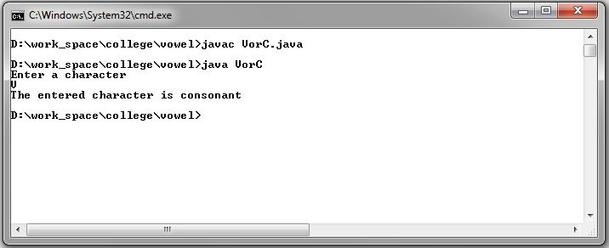

1. Assume a vehicle plate number consists of three uppercase letters followed by four digits. Write a program to generate a plate number.

import java.util.*;

class Plate

{

public static void main(String args[])

{

int a,b,c,d;

char x,y,z;

Random r= new Random();

x=(char)(r.nextInt(26)+'A');

y=(char)(r.nextInt(26)+'A');

z=(char)(r.nextInt(26)+'A');

a=r.nextInt(10);

b=r.nextInt(10);

c=r.nextInt(10);

d=r.nextInt(10);

System.out.println(x+" "+y+" "+z);

System.out.println(a+" "+b+" "+c+" "+d);

}

}

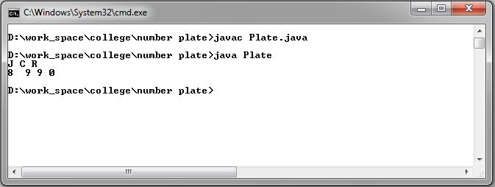

1. Write a program that reads an integer and displays all its smallest factors in increasing order. For example if input number is 120, the output should be as follows:2,2,2,3,5.

import java.util.Scanner;

class Fac

{

public static void main(String args[])

{

int rem,div;

Scanner sc=new Scanner(System.in);

System.out.println(" Enter a value");

int value=sc.nextInt();

System.out.println("Factorials are:---");

for(int i=2;i<=9;i++)

{

while(value%i==0)

{

System.out.println(i);

value=value/i;

}

}

}

}

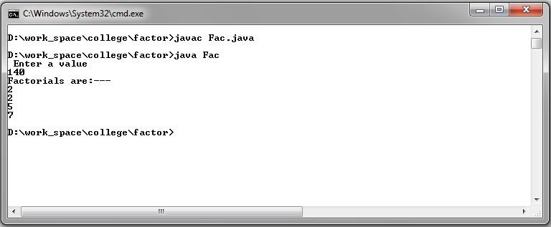

1. Write a method with following method header. public static int gcd(int num1, int num2) Write a program that prompts the user to enter two integers and compute the gcd of two integers.

import java.util.*;

class op

{

public static int gcd(int a,int b)

{

int sel;

if(a>b)

{

sel=a;

}

else

{

sel=b;

}

for(int i=sel;i>=1;i--)

{

if(a%i==0 && b%i==0)

{

return i;

}

}

return 0;

}

}

class Main

{

public static void main(String args[])

{

Scanner sc =new Scanner(System.in);

int a,b;

System.out.println("ENTER TWO NUMBER ");

a=sc.nextInt();

b=sc.nextInt();

int gcd=op.gcd(a,b);

System.out.println("GCD IS = "+gcd);

}

}

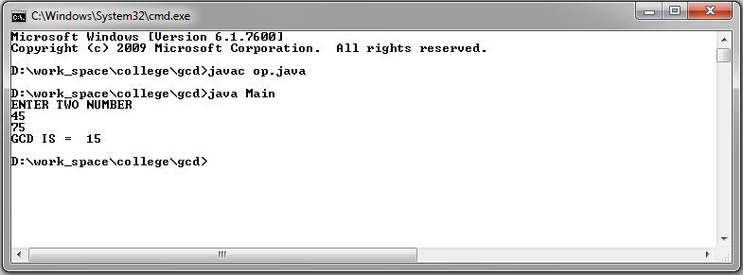

1. Write a test program that prompts the user to enter ten numbers, invoke a method to reverse the numbers, display the numbers.

import java.util.Scanner;

class Operation

{

static void rev(int a[])

{

int len=a.length;

for(int i=0;i<len;i++)

{

int temp=0;

while(a[i]>0)

{

temp=(temp*10)+(a[i]%10);

a[i]=a[i]/10;

}

System.out.println(temp);

}

}

}

class Main

{

public static void main(String args[])

{

Scanner sc= new Scanner(System.in);

int num[] = new int[10];

System.out.println("Enter 10 numbers");

for(int i=0;i<10;i++)

{

num[i]=sc.nextInt();

}

System.out.println("Reversed number are");

Operation.rev(num);

}

}

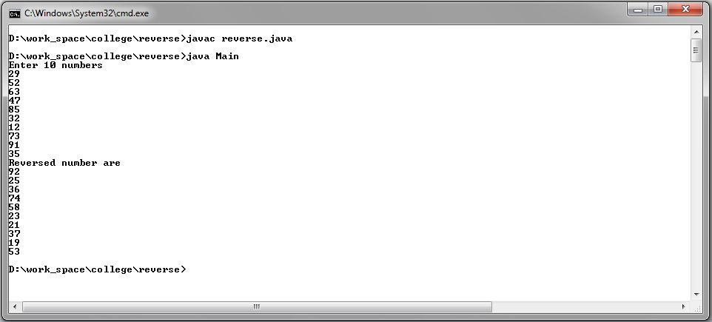

11). Write a program that generate 6*6 two-dimensional matrix, filled with 0’s and 1’s , display the matrix, check every raw and column have an odd number’s of 1’s.

public class Mat

{

public static void main(String args[])

{

int a[][] = new int[6][6] ;

int temp;

int x=0;

int y=1;

for(int i=0;i<=5;i++)

{

for(int j=0;j<=5;j++)

{

if(j%2==0)

{

a[i][j]=x;

}

else

{

a[i][j]=y;

}

}

temp=x;

x=y;

y=temp;

}

for(int i=0;i<=5;i++)

{

for(int j=0;j<=5;j++)

{

System.out.print(a[i][j]+" ");

}

System.out.println(" ");

}

}

}

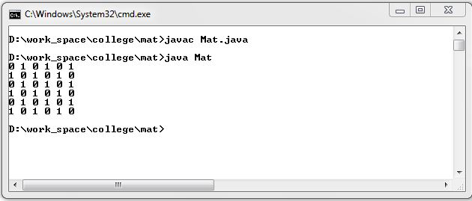

12) Write a program that creates a Random object with seed 1000 and displays the first  100  random integers between 1 and 49 using the NextInt (49) method.

import java.util.Random;

public class RandomNum

{

public static void main(String[] args)

{

Random rand = new Random(1000);

for (int i = 0; i < 100; i++)

{

System.out.format("%3d",rand.nextInt(49));

if((i+1)%20==0)

{

System.out.println();

}

}

}

}

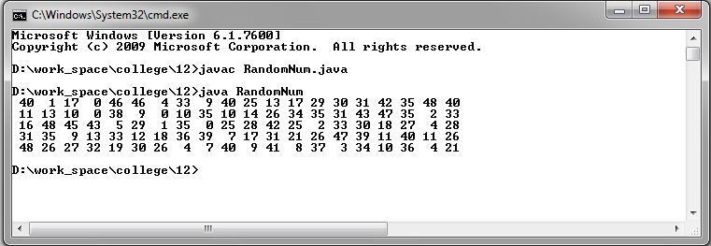

13) Write a program for calculator to accept an expression as a string in which the operands and operator are separated by zero or more spaces. For ex: 3+4 and 3 + 4 are acceptable expressions.

import java.util.Scanner;

public class Calculator

{

public static void main(String[] args)

{

Scanner input = new Scanner(System.in);

System.out.print("Enter Equation : ");

String str = input.nextLine();

String a = str.replaceAll(" ","");

if (a.length() < 3) {

System.out.println(

"Minimum 2 Opearator and 1 Opearand Required");

System.exit(0);

}

int result = 0;

int i = 0;

while(a.charAt(i)!='+' && a.charAt(i)!='-' && a.charAt(i)!='*' && a.charAt(i)!='/')

{

i++;

}

switch (a.charAt(i)) {

case '+' :

result = Integer.parseInt(a.substring(0,i))+Integer.parseInt(a.substring(i+1,a.length()));

break;

case '-' :

result = Integer.parseInt(a.substring(0,i))-Integer.parseInt(a.substring(i+1,a.length()));

break;

case '*' :

result = Integer.parseInt(a.substring(0,i))*Integer.parseInt(a.substring(i+1,a.length()));

break;

case '/' :

result = Integer.parseInt(a.substring(0,i))/Integer.parseInt(a.substring(i+1,a.length()));

break;

}

System.out.println(a.substring(0,i) + ' ' + a.charAt(i) + ' ' + a.substring(i+1,a.length())

+ " = " + result);

}

}

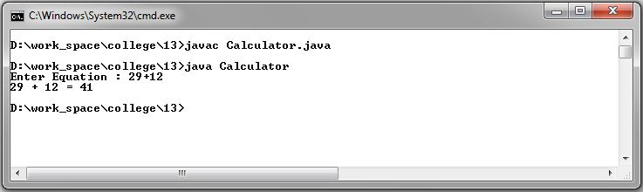

14) Write a program that creates an Array List and adds a Loan object, a Date object, a string, and a Circle object to the list, and use a loop to display all elements in the list by invoking the object’s to String() method.

import java.util.ArrayList;

import java.util.Date;

public class Loan0

{

public static void main(String[] args)

{

ArrayList<Object> arr_list = new ArrayList<Object>();

arr_list.add(new Loan(5000.50));

arr_list.add(new Date());

arr_list.add(new String("String class"));

arr_list.add(new Circle(3.45));

for (int i = 0; i < arr_list.size(); i++)

{

System.out.println((arr_list.get(i)).toString());

}

}

}

class Circle

{

double radius;

Circle(double r)

{

this.radius=r;

}

public String toString()

{

return "Circle with Radius "+this.radius;

}

}

class Loan

{

double amount;

Loan(double amt)

{

this.amount=amt;

}

public String toString()

{

return "Loan with Amount "+this.amount;

}

}

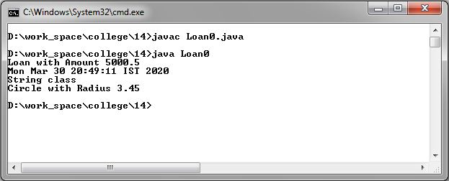

15) Write the bin2Dec (string binary String) method to convert a binary string into a decimal number. Implement the bin2Dec method to throw a  NumberFormatException if the string is not a binary string.

import java.util.Scanner;

public class Converter

{

public static int bin2Dec(String binaryString) throws NumberFormatException

{

int decimal = 0;

int strLength=binaryString.length();

for (int i = 0; i < strLength; i++)

{

if (binaryString.charAt(i) < '0' || binaryString.charAt(i) > '1')

{

throw new NumberFormatException("The Input String is not Binary");

}

decimal += (binaryString.charAt(i)-'0') * Math.pow(2, strLength-1-i);

}

return decimal;

}

public static void main(String[] args)

{

Scanner input = new Scanner(System.in);

System.out.print("Enter Binary Value : ");

String str = input.nextLine();

try

{

System.out.println("Value = " + bin2Dec(str));

}

catch(NumberFormatException e)

{

System.out.println(e);

}

}

}

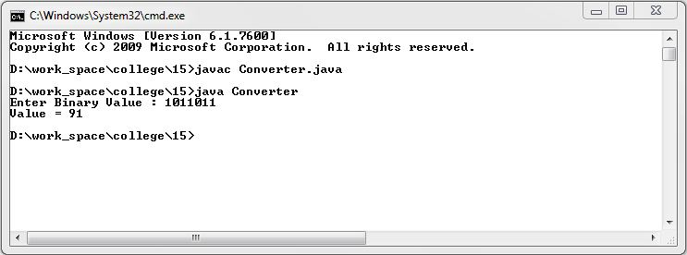

16) Write a program that prompts the user to enter a decimal number and displays the number in a fraction.Hint: Read the decimal number as a string,  extract the integer part and fractional part from the string.

import java.util.Scanner;

public class Frac

{

public static void main(String[] args)

{

Scanner input = new Scanner(System.in);

System.out.println("Enter a decimal value");

String[] str= input.nextLine().split("\\.");

System.out.println("Number part is "+str[0]);

System.out.println("Fraction part is "+str[1]);

}

}

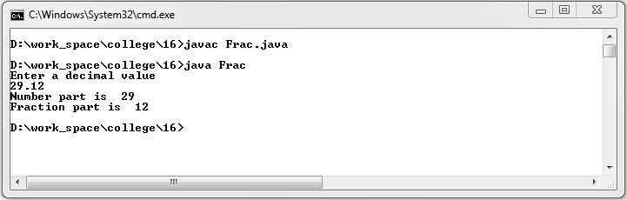

17) Write a program that displays a tic-tac-toe board. A cell may be X, O, or empty. What to display at each cell is randomly decided. The X and O are images in the files X.gif and O.gif.

import javafx.application.Application;

import javafx.scene.Scene;

import javafx.scene.layout.GridPane;

import javafx.scene.control.Label;

import javafx.scene.image.Image;

import javafx.scene.image.ImageView;

import javafx.stage.Stage;

public class Board extends Application

{

@Override

public void start(Stage primaryStage)

{

GridPane pane = new GridPane();

for (int i = 0; i < 3; i++)

{

for (int j = 0; j < 3; j++)

{

int n = (int)(Math.random() * 3);

if (n == 0)

pane.add(new ImageView(new Image(getClass().getClassLoader().getResource("X.png").toString(), true)), j, i);

else if (n == 1)

pane.add(new ImageView(new Image(getClass().getClassLoader().getResource("0.png").toString(), true)), j, i);

else

continue;

}

}

Scene scene = new Scene(pane, 120, 130);

primaryStage.setTitle("OOP_17");

primaryStage.setScene(scene);

primaryStage.show();

}

public static void main(String args[])

{

launch(args);

}

}

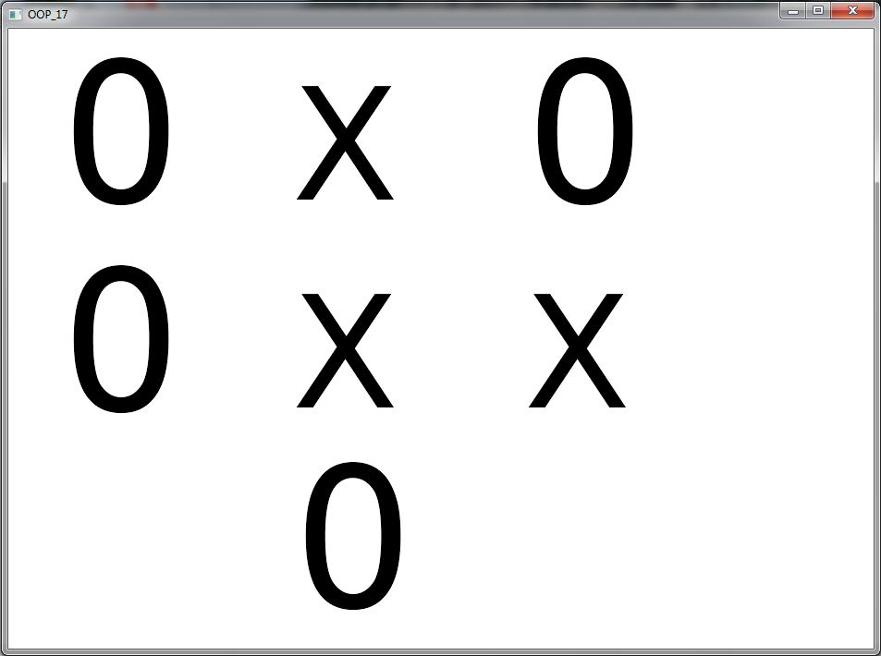

18) Write a program that moves a circle up, down, left or right using arrow keys.

import javafx.application.Application;

import javafx.scene.Scene;

import javafx.scene.shape.Circle;

import javafx.scene.layout.Pane;

import javafx.geometry.Insets;

import javafx.stage.Stage;

public class Cir extends Application

{

@Override

public void start(Stage primaryStage) {

Pane pane = new Pane();

pane.setPadding(new Insets(30, 30, 30, 30));

Circle circle = new Circle(30, 30, 30);

pane.getChildren().add(circle);

pane.setOnKeyPressed(e -> {

switch (e.getCode()) {

case UP : circle.setCenterY(circle.getCenterY() >

circle.getRadius() ? circle.getCenterY() - 15 :

circle.getCenterY()); break;

case DOWN : circle.setCenterY(circle.getCenterY() <

pane.getHeight() - circle.getRadius() ?

circle.getCenterY() + 15 : circle.getCenterY());

break;

case LEFT : circle.setCenterX(circle.getCenterX() >

circle.getRadius() ? circle.getCenterX() - 15 :

circle.getCenterX()); break;

case RIGHT : circle.setCenterX(circle.getCenterX() <

pane.getWidth() - circle.getRadius() ?

circle.getCenterX() + 15: circle.getCenterX());

}

});

Scene scene = new Scene(pane, 200, 200);

primaryStage.setTitle("OOP_18");

primaryStage.setScene(scene);

primaryStage.show();

pane.requestFocus();

}

}

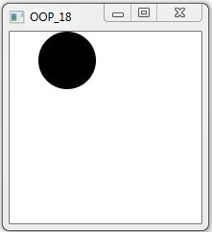

19) Write a program that displays the color of a circle as red when the mouse button is pressed and as blue when the mouse button is released.

import javafx.application.Application;

import javafx.scene.Scene;

import javafx.scene.layout.StackPane;

import javafx.scene.paint.Color;

import javafx.scene.shape.Circle;

import javafx.stage.Stage;

public class Vedant extends Application

{

@Override

public void start(Stage primaryStage)

{

double width = 450;

double height = 450;

Circle c = new Circle(width / 2, height / 2, Math.min(width, height) / 10, Color.BLUE);

c.setStroke(Color.WHITE);

StackPane pane = new StackPane(c);

primaryStage.setScene(new Scene(pane, width, height));

pane.setOnMousePressed(e -> c.setFill(Color.RED));

pane.setOnMouseReleased(e -> c.setFill(Color.BLUE));

primaryStage.setTitle("Click circle..");

primaryStage.show();

}

public static void main(String[] args) {

Application.launch(args);

}

}

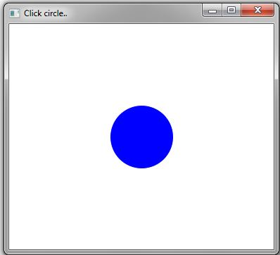

20) Write a GUI program that use button to move the message to the left and right and use the radio button to change the color for the message displayed.

import javafx.application.Application;

import javafx.stage.Stage;

import javafx.scene.Scene;

import javafx.geometry.Pos;

import javafx.scene.control.Button;

import javafx.scene.layout.HBox;

import javafx.scene.layout.Pane;

import javafx.scene.layout.BorderPane;

import javafx.scene.text.Text;

import javafx.scene.control.RadioButton;

import javafx.scene.control.ToggleGroup;

import javafx.scene.paint.Color;

public class FXC extends Application

{

protected Text text = new Text(50, 50, "CodingKick");

@Override

public void start(Stage primaryStage) {

HBox paneForButtons = new HBox(20);

Button btLeft = new Button("<=");

Button btRight = new Button("=>");

paneForButtons.getChildren().addAll(btLeft, btRight);

paneForButtons.setAlignment(Pos.CENTER);

BorderPane pane = new BorderPane();

pane.setBottom(paneForButtons);

HBox paneForRadioButtons = new HBox(20);

RadioButton rbRed = new RadioButton("Red");

RadioButton rbYellow = new RadioButton("Yellow");

RadioButton rbBlack = new RadioButton("Black");

RadioButton rbOrange = new RadioButton("Orange");

RadioButton rbGreen = new RadioButton("Green");

paneForRadioButtons.getChildren().addAll(rbRed, rbYellow,

rbBlack, rbOrange, rbGreen);

ToggleGroup group = new ToggleGroup();

rbRed.setToggleGroup(group);

rbYellow.setToggleGroup(group);

rbBlack.setToggleGroup(group);

rbOrange.setToggleGroup(group);

rbGreen.setToggleGroup(group);

Pane paneForText = new Pane();

paneForText.setStyle("-fx-border-color: black");

paneForText.getChildren().add(text);

pane.setCenter(paneForText);

pane.setTop(paneForRadioButtons);

btLeft.setOnAction(e -> text.setX(text.getX() - 10));

btRight.setOnAction(e -> text.setX(text.getX() + 10));

rbRed.setOnAction(e -> {

if (rbRed.isSelected()) {

text.setFill(Color.RED);

}

});

rbYellow.setOnAction(e -> {

if (rbYellow.isSelected()) {

text.setFill(Color.YELLOW);

}

});

rbBlack.setOnAction(e -> {

if (rbBlack.isSelected()) {

text.setFill(Color.BLACK);

}

});

rbOrange.setOnAction(e -> {

if (rbOrange.isSelected()) {

text.setFill(Color.ORANGE);

}

});

rbGreen.setOnAction(e -> {

if (rbGreen.isSelected()) {

text.setFill(Color.GREEN);

}

});

Scene scene = new Scene(pane, 450, 150);

primaryStage.setTitle("OOP_20");

primaryStage.setScene(scene);

primaryStage.show();

}

public static void main(String[] args) {

Application.launch(args);

}

}

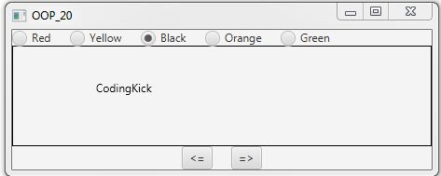

21) Write a program to create a file name 123.txt, if it does not exist. Append a new data to it if it already exists.  Write  150  integers created randomly into the file using  Text  I/O.  Integers are separated by space.

import java.io.*;

import java.util.Scanner;

public class RFile

{

public static void main(String[] args)

{

try (

PrintWriter pw = new PrintWriter(new FileOutputStream(new File("123.txt"), true));

) {

for (int i = 0; i < 150; i++)

{

pw.print((int)(Math.random() * 150) + " ");

}

}

catch (FileNotFoundException fnfe)

{

System.out.println("Cannot create the file.");

fnfe.printStackTrace();

}

}

}

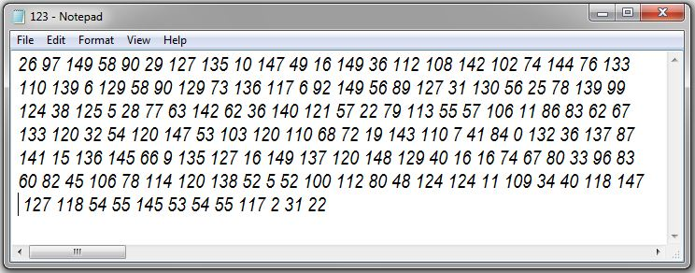

22) Write a recursive method that returns the smallest integer in an array.  Write a test program that prompts the user to enter an integer and display its product.

import java.util.Scanner;

public class Vedant

{

public static void main(String[] args)

{

Scanner input = new Scanner(System.in);

System.out.print("Enter five integers: ");

int[] list = new int[5];

for (int i = 0; i < list.length; i++)

{

list[i] = input.nextInt();

}

System.out.println("The smallest element is " + min(list));

}

public static int min(int[] list)

{

int min = list[list.length - 1];

int index = list.length - 1;

return min(list, index, min);

}

private static int min(int[] list, int index, int min)

{

if (index < 0)

{

return min;

}

else if (list[index] < min)

{

return min(list, index - 1, list[index]);

}

else

{

return min(list, index - 1, min);

}

}

}

import java.util.Scanner;

public class Vedant1

{

public static void main(String[] args)

{

Scanner input = new Scanner(System.in);

int product=1;

System.out.print("Enter five integers: ");

int[] list = new int[5];

for (int i = 0; i < list.length; i++)

{

list[i] = input.nextInt();

product *= list[i];

}

System.out.println("The Product of elements is " + product);

}

}

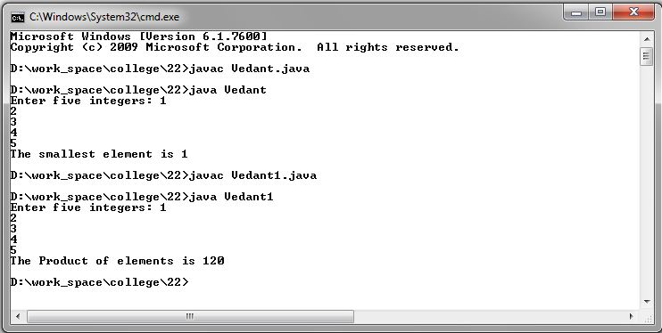

23) Write a generic method that returns the minimum elements in a two dimensional array.

import java.util.Scanner;

public class Gen

{

public static void main(String[] args)

{

Integer[][] list = new Integer[10][10];

int value = 0;

for (int i = 0; i < list.length; i++)

{

for (int j = 0; j < list[i].length; j++)

{

list[i][j] = value++;

}

}

System.out.println("Max = " + max(list));

}

public static <E extends Comparable<E>> E max(E[][] list)

{

E max = list[0][0];

for (E[] elements : list)

{

for (E element : elements)

{

if (element.compareTo(max) > 0)

{

max = element;

}

}

}

return max;

}

}

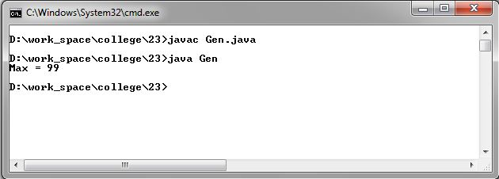

24) Define  MYPriorityQueue class that extends Priority Queue to implement the  Cloneable interface and implement the clone() method to clone a priority queue.

import java.util.PriorityQueue;

public class QU

{

public static void main(String[] args)

{

MyPriorityQueue<String> queue = new MyPriorityQueue<>();

queue.offer("1");

queue.offer("2");

queue.offer("3");

MyPriorityQueue<String> queue1 = null;

try

{

queue1 = (MyPriorityQueue<String>)(queue.clone());

}

catch (CloneNotSupportedException e)

{

e.printStackTrace();

}

System.out.print(queue1);

}

static class MyPriorityQueue<E> extends PriorityQueue<E> implements Cloneable

{

@Override

public Object clone() throws CloneNotSupportedException

{

MyPriorityQueue<E> clone = new MyPriorityQueue<>();

this.forEach(clone::offer);

return clone;

}

}

}

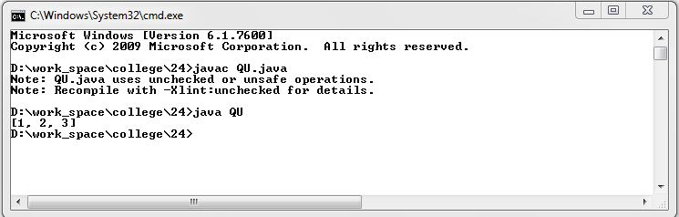

25) Write a program that reads words from a text file and displays all the nonduplicate words in descending order. The text file is passed as a command-line argument.

import java.io.*;

import java.security.InvalidParameterException;

import java.util.Arrays;

import java.util.HashSet;

import java.util.TreeSet;

import java.util.Collections;

import java.util.Iterator;

public class OOP25

{

public static void main(String[] args) throws FileNotFoundException

{

if (args.length != 1)

throw new InvalidParameterException("Usage: fullFilePathName");

File file = new File(args[0]);

if (!file.isFile())

throw new FileNotFoundException(file + " is not a file.");

try (BufferedReader in = new BufferedReader(new InputStreamReader(new FileInputStream(file)), 10000))

{

String inputS;

StringBuilder sb = new StringBuilder(10000);

while ((inputS = in.readLine()) != null)

sb.append(inputS);

String[] words = sb.toString().split("\\s+");

TreeSet<String> ndWords = new TreeSet<>(Arrays.asList(words));

Iterator<String> itr = ndWords.descendingIterator();

String s;

while (itr.hasNext())

{

s = itr.next();

System.out.println(s);

}

}

catch (IOException e)

{

e.printStackTrace();

System.exit(0);

}

}

}

